**American International University Bangladesh**

**Course Title:** Introduction to Database

**Faculty:** SIFAT RAHMAN AHONA

**Section:** L

**Group Number:** 10

**Project title:**Pastry shop management system

|  |  |
| --- | --- |
| ID | Name |
| 19-39809-1 | Nebadeta Nath Tonney |
| 19-39835-1 | Dardina Sara Narisha Dardina Sara Narisha |
| 19-39821-1 | Nazmun Nahar Akhi Nazmun Nahar Akhi |
| 19-40403-1 | Turzo Roy |

***Pastry shop management system***

**Introduction**

The project is about Pastry shop management system. We try to make a better management system that will help both the owner and employees to maintain orders and customer satisfaction easily and also keep records of everything related to sell. The management system keeps data of every customer's name, order, table number, bill number and amount to be paid. The pastry shop also sells raw products. The system keeps a data of the raw products sold to the consumers. The pastry shop stores the item names, codes and prices. Bill number and bill amount are also stored. The system has every data stored for the employee details like their Id, name, salary, address, phone number, designation, joining date. This database management system will help keep track of orders, employees and deliveries. At last, we would try to create a database management system that will be easier to use for the operators and useful for the pastry shop.

**ER diagram**

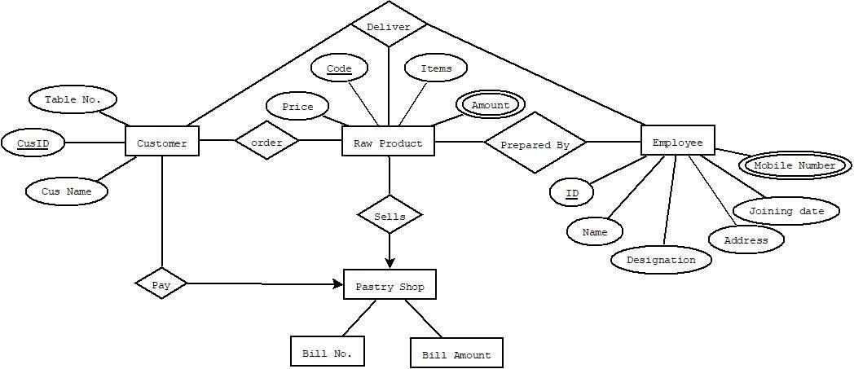

# **NORMALIZATION**

**Prepared By** (**id**, name, salary, designation, address, mobile number, joining date, code, items, price, amount)

1 NF: **mobile number and amount are multivalued attribute.**

2 NF: id, name, salary, designation, address, mobile number, joining date;

code, items, price, amount;

3 NF: Id, name, address, joining date;

sid, salary, designation, mobile number;

code, items, price, amount;

**Table :**

Id, name, address, joining date;

sid, salary, designation, mobile number;

code, items, price, amount;

**order**(cus id, cus name, table no, code, items, price, amount)

1 NF: **Amount is a multivalued attribute.**

2 NF: cus id, cus name, table no;

code, items, price, amount;

3 NF: **No transitive dependency.**

cus id, cus name, table no;

code, items, price, amount;

**Table** :

cus id, cus name, table no;

code, items, price, amount;

**pay**(cus id, cus name, table no, bill no, bill_ amount)

1 NF: **No multivalued attribute.**

2 NF: cus id, cus name, table no;

bill no, bill_ amount;

3 NF: **No transitive dependency.**

cus id, cus name, table no;

bill no, bill_ amount;

**Table :**

cus id, cus name, table no;

bill no, bill_amount;

**sells** (code, items, price, amount, bill no, bill_ amount)

1 NF: **Amount is a multivalued attribute.**

2 NF: code, items, price, amount;

bill no, bill_ amount;

3 NF: **No transitive dependency.**

code, items, price, amount;

bill no, bill_ amount;

**Table:**

code, items, price,amount;

bill no, bill_ amount;

**deliver**(cus id, cus name, table no, id, name, salary, designation, address, mobile number, joining date)

1 NF: **Mobile number is a multivalued attribute.**

2 NF: cus id, cus name, table no;

id, name, salary, designation, address, mobile number, joining date;

3 NF: cus id, cus name, table no;

id, name, address, mobile number, joining date;

sid, salary, designation;

**Table:**

cus id, cus name, table no;

id, name, address, mobile number, joining date;

sid, salary, designation;

**Total Table:**

~~Id, name, address, joining date;~~

sid, salary, designation, mobile number;

~~code, items, price, amount;~~

~~cus id, cus name, table no;~~

~~code, items, price, amount;~~

cus id, cus name, table no;

bill no, bill_amount;

code, items, price,amount;

~~bill no, bill_ amount;~~

~~cus id, cus name, table no;~~

id, name, address, mobile number, joining date;

~~sid, salary, designation;~~

**Final Table:**

sid, salary, designation, mobile number;

cus id, cus name, table no;

bill no, bill_amount;

code, items, price,amount;

id, name, address, mobile number, joining date;

**Table Creation**

1.Table:

CREATE TABLE my_table

(

salary number(20)not null,

designation varchar(30)not null,

mobile_no number(35)

);

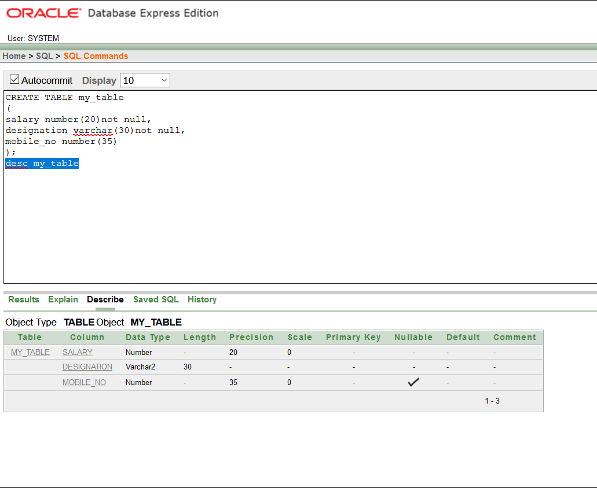

2.table:

CREATE TABLE customer_

(

id number (4)unique,

name varchar(10)not null,

table_no number(3)

);

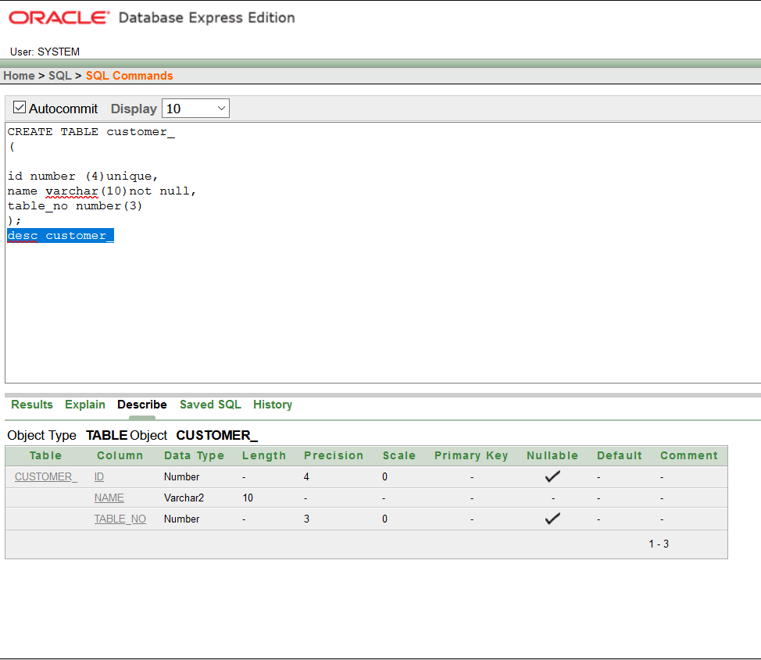

3.Table

CREATE TABLE customer_bill

(

bill_no number (10)not null,

bill_amount number(15)not null

); CREATE TABLE customer_bill

(

bill_no number (10)not null,

bill_amount number(15)not null

);

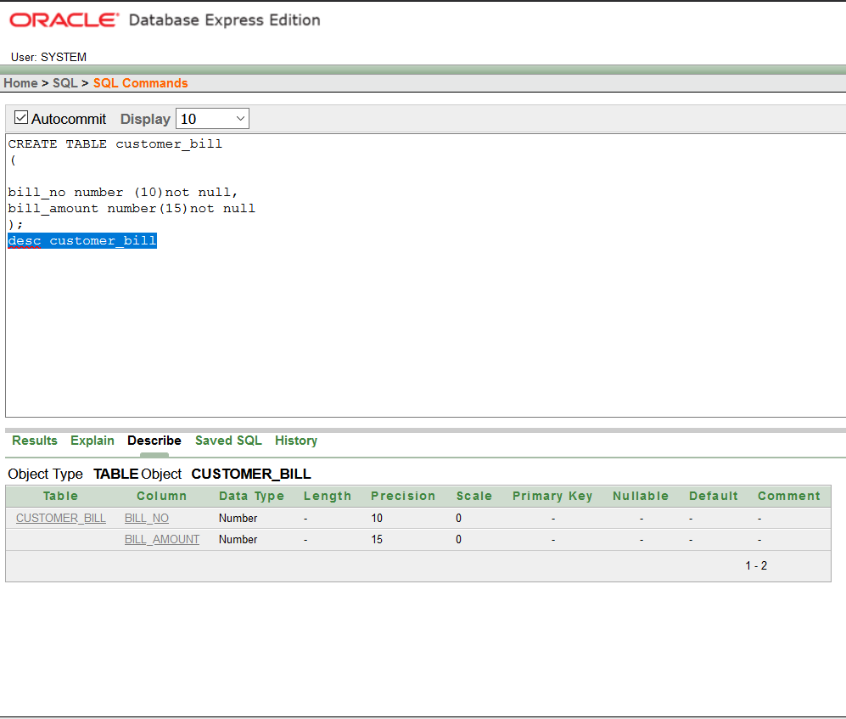

4.table:

CREATE TABLE product_

(

code number (4)unique,

item varchar(10),

price number(3)not null,

amount number(5)

);

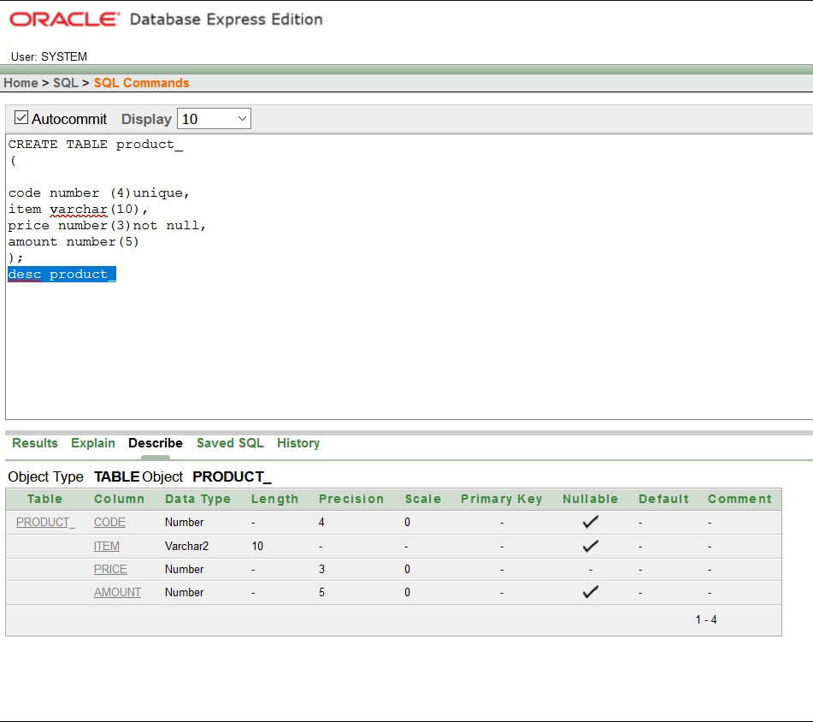

5.table:

CREATE TABLE employees_

(

id number(4)unique,

name varchar(10)not null,

address varchar(30),

mobile number(20)not null,

joiningdate date not null

);

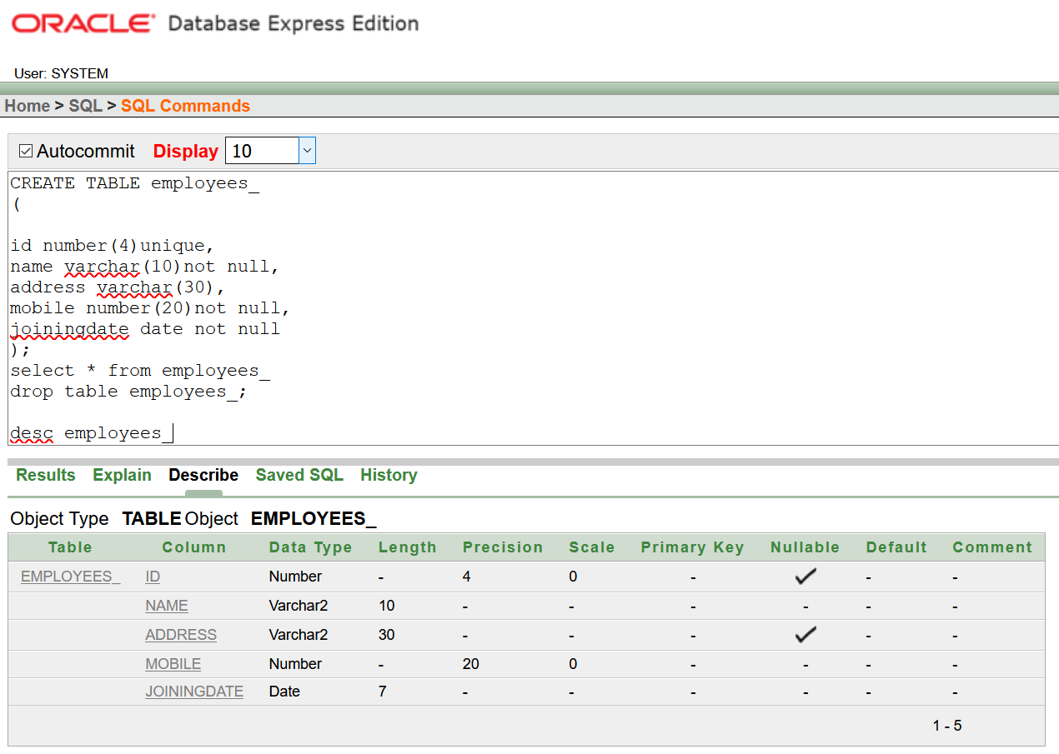

**Data insertion**

1. INSERT INTO my_table (SALARY, DESIGNATION, MOBILE_NO)

VALUES (5000, 'WAITER', 985005636);

INSERT INTO my_table

VALUES (8000, 'RECEPTIONIST', 985545636);

INSERT INTO my_table

VALUES (10000, 'CHEF', 982355636);

INSERT INTO my_table

VALUES (8000, 'MANAGER', 985763936);

SELECT * FROM my_table;

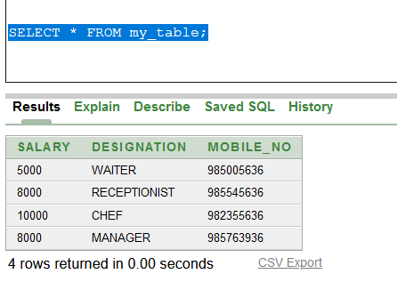

2. desc customer_

INSERT INTO customer_ (ID, NAME,TABLE_NO)

VALUES (2118, 'S Rogers', 03);

INSERT INTO customer_ (ID, NAME,TABLE_NO)

VALUES (2119, 'T Stark', 04);

INSERT INTO customer_ (ID, NAME,TABLE_NO)

VALUES (2120, 'T Challa', 05);

INSERT INTO customer_ (ID, NAME,TABLE_NO)

VALUES (2121, 'Dr Banner', 06);

SELECT * FROM customer_;

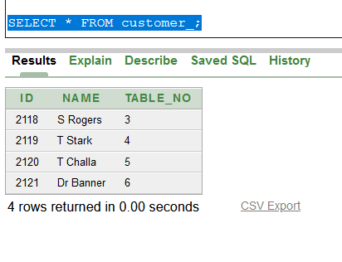

3. desc customer_bill

INSERT INTO customer_bill (BILL_NO, BILL_AMOUNT)

VALUES (32, 1500);

INSERT INTO customer_bill (BILL_NO, BILL_AMOUNT)

VALUES (34, 1800);

INSERT INTO customer_bill (BILL_NO, BILL_AMOUNT)

VALUES (355, 2500);

INSERT INTO customer_bill (BILL_NO, BILL_AMOUNT)

VALUES (40, 3500);

SELECT * FROM customer_bill;

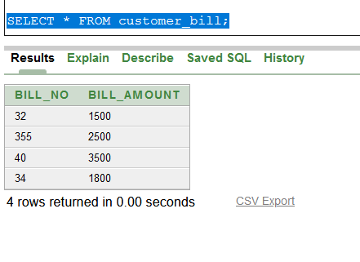

4. desc product_

INSERT INTO product_ (CODE, ITEM, PRICE, AMOUNT)

VALUES (203, 'red velvet', 500, 540);

INSERT INTO product_ (CODE, ITEM, PRICE, AMOUNT)

VALUES (204, 'Pound', 400, 430);

INSERT INTO product_ (CODE, ITEM, PRICE, AMOUNT)

VALUES (205, 'Chesnut', 600, 650);

INSERT INTO product_ (CODE, ITEM, PRICE, AMOUNT)

VALUES (206, 'Carrot', 620, 660);

SELECT * FROM product_;

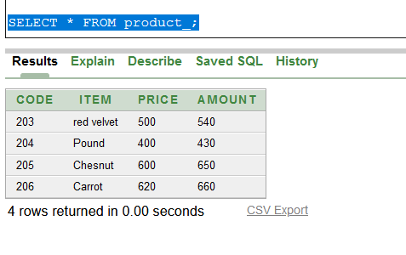

**Sequence**

5. desc employees

create sequence empseq start with 1021 increment by 1;

INSERT INTO employees_ (ID, NAME, ADDRESS, MOBILE, JOININGDATE)

VALUES (empseq.nextval, 'TONNEY', 'KHAN MANJIL', 13215415441, (to_date('02/02/02','dd/mm/yyyy'))

);

INSERT INTO employees_ (ID, NAME, ADDRESS, MOBILE, JOININGDATE)

VALUES (empseq.nextval, 'AKHI', 'BASUNDHORA', 14682415441, (to_date('03/03/03','dd/mm/yyyy'))

);

INSERT INTO employees_ (ID, NAME, ADDRESS, MOBILE, JOININGDATE)

VALUES (empseq.nextval, 'SARA', 'BASUNDHORA', 14682574441, (to_date('04/04/04','dd/mm/yyyy'))

);

INSERT INTO employees_ (ID, NAME, ADDRESS, MOBILE, JOININGDATE)

VALUES (empseq.nextval, 'TURZO', 'KURIL', 14648137441, (to_date('04/04/04','dd/mm/yyyy')));

select * from employees_

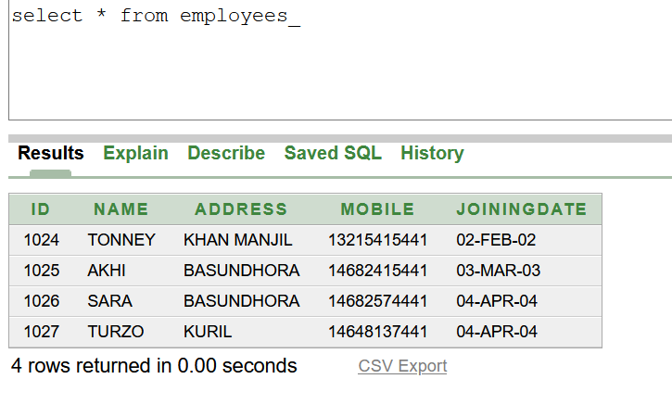

**Query writing:**

1.**Sub query**

Q:Write a sql query to display the designation who is taking the maximum salary from my_table table.

A: SELECT DESIGNATION FROM MY_TABLE WHERE SALARY= (SELECT MAX (SALARY) FROM MY_TABLE);

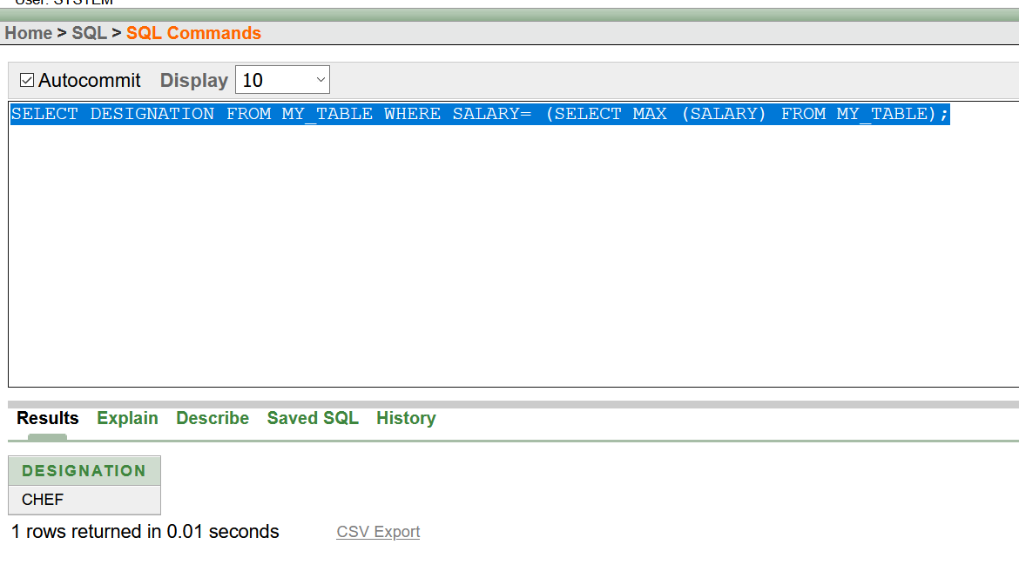

2.**Group function**

Q: find the bill number of customer_bill who have paid more than 1800.

A:select count(bill_no) from customer_bill where bill_amount>1800

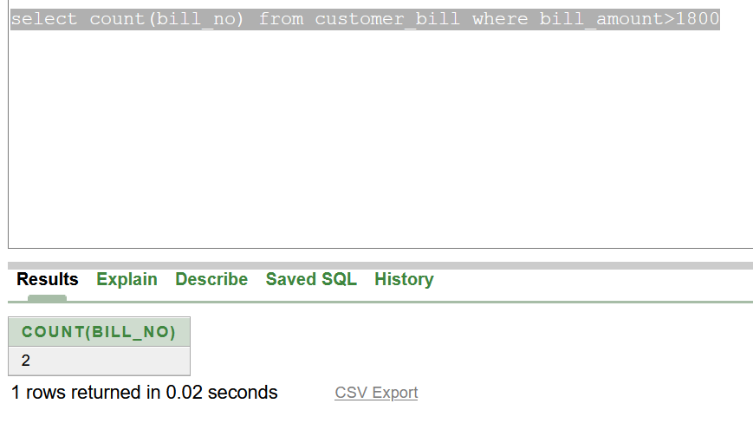

3.**Single row function**

Q: print code number and price from product_ table and price in ascending order.

A: select code "code",price "price"from product_ order by price asc

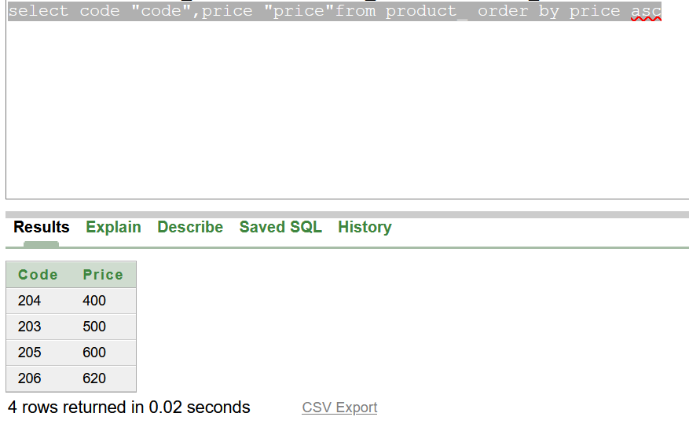

**Relational Algebra:**

**1.** bill_no(bill_amount>1800(customer_bill))